Project Proposal: PaySprint Investment Agent

Group 6
Data Engineer: Reema Eid AI Engineer: Hyunju Yu Project Management: Quang Tran

Company Name and Industry
PaySprint Investments is a financial technology company in the personal investing industry. The company focuses on helping retail investors research stocks, compare opportunities, create purchase plans, and make more confident investment decisions. PaySprint AI's primary audience is growth-focused retail investors, particularly those drawn to IPOs and early-stage public companies, as well as the rapidly expanding AI and technology sector. The goal of PaySprint is to build an AI powered investing tool that works similar to a modern brokerage research platform, but with AI-driven personalization and automation.
Use Case and Business Value
The use case for this project is an AI powered stock research and purchase planning agent. The agent will help users research stocks, compare investment opportunities, choose an investment strategy, and create a purchase plan based on their available budget and risk preference. The user can select an aggressiveness level, such as conservative, moderate, or aggressive. Based on that level, the agent will adjust the recommended stocks, allocation percentages, and purchase plan.
The business value is that PaySprint AI can offer users a complete investing workflow instead of only providing research. Many tools help users look up stock information, but users still have to decide what to buy, how much to buy, and whether the plan matches their risk level. PaySprint’s agent connects research, strategy selection, purchase planning, and portfolio allocation into one guided experience.
Relevance, In House Development, and Estimated ROI
This use case is relevant because many retail investors want to invest but do not know how to turn stock research into a clear purchase decision. A user may read news, look at charts, and compare financial ratios, but still feel unsure about what action to take. PaySprint solves this problem by creating an agent that behaves more like a personalized investing assistant. It can research stocks, explain opportunities, rank choices, and create a buy plan that fits the user’s financial situation.
Building this agent in house is important because PaySprint needs full control over the recommendation logic, risk settings, scoring model, and user experience. A third party brokerage tool may provide stock screeners and research, but it may not create a personalized purchase plan based on the user’s paycheck, budget, current holdings, and selected aggressiveness level. A general AI chatbot may explain stocks, but it usually does not combine live market data, technical analysis, fundamentals, sentiment, and share count allocation in one complete workflow.
The potential ROI is strong because the agent can save users time and help them make more disciplined decisions. If the agent saves a user four hours of research per week, and that time is valued at twenty five dollars per hour, the yearly time savings could be around five thousand two hundred dollars. The agent may also help users avoid emotional or poorly researched trades. If the yearly operating cost is around one hundred eighty dollars per user, the value delivered could be much higher than the cost.
Dataset Identification
The agent will use several datasets to support stock research and purchase planning. The first dataset is historical stock price data from Yahoo Finance through the yfinance Python library. This includes open, high, low, close, adjusted close, and volume data. The second dataset is company fundamental data from yfinance, including price to earnings ratio, earnings per share, revenue growth, debt to equity ratio, free cash flow, market capitalization, sector, and industry.
The third dataset is financial news from GNews API, which provides recent articles about companies and market trends. The fourth dataset is company specific news and sentiment data from Finnhub API. The fifth dataset is user profile data, including investment budget, risk tolerance, aggressiveness level, investment horizon, current holdings, and preferred sectors.
Dataset Appropriateness and Tooling
These datasets are appropriate because they support the same type of information a brokerage style research tool needs. Price data helps the agent analyze trends, momentum, volatility, and recent performance. Fundamental data helps the agent evaluate company quality and long term strength. News and sentiment data help the agent identify recent events that may affect a stock. User profile data allows the agent to personalize the purchase plan instead of giving the same recommendation to every investor.
The tools used for this dataset will include pandas and numpy for data cleaning and analysis, yfinance for price and fundamental data, pandas ta for technical indicators, scikit learn for momentum and trend analysis, NLTK VADER for sentiment scoring, spaCy for identifying company names in news text, PyPortfolioOpt for allocation planning, Pydantic for data validation, and SQLite for saving user profiles and recommendation history.
This dataset is reasonable for the course timeline because the tools and data sources are easy to access. yfinance does not require an API key, and Finnhub and GNews can be accessed through free or low cost accounts. This allows the team to build a working prototype quickly and focus on the agent design, risk logic, and evaluation.
High Level Technical Plan
The agent will use a large language model as the main reasoning system. Claude Haiku or a smaller GPT model can be used for individual stock summaries because those tasks are shorter and lower cost. Claude Sonnet or GPT 5 can be used for the final portfolio report because the model needs to reason across all stocks, user preferences, risk level, and allocation results.
The agent will use several tools. A stock screener tool will filter stocks based on user preferences and aggressiveness level. A price history tool will retrieve recent stock prices. A fundamentals tool will retrieve company financial metrics. A news sentiment tool will summarize recent news and score sentiment. A technical indicator tool will calculate RSI, MACD, volatility, and momentum. A purchase planning tool will calculate how many shares the user can buy with the available budget. A portfolio allocation tool will distribute the budget across recommended stocks based on the selected risk level.
The agent will be evaluated in three ways. First, backtesting will compare historical recommendations against the S&P 500. Second, an LLM judge will review each report for reasoning quality, risk alignment, clarity, and purchase plan accuracy. Third, consistency testing will check whether the agent gives similar recommendations when the same data and user profile are used again.
Intended Architecture Diagram
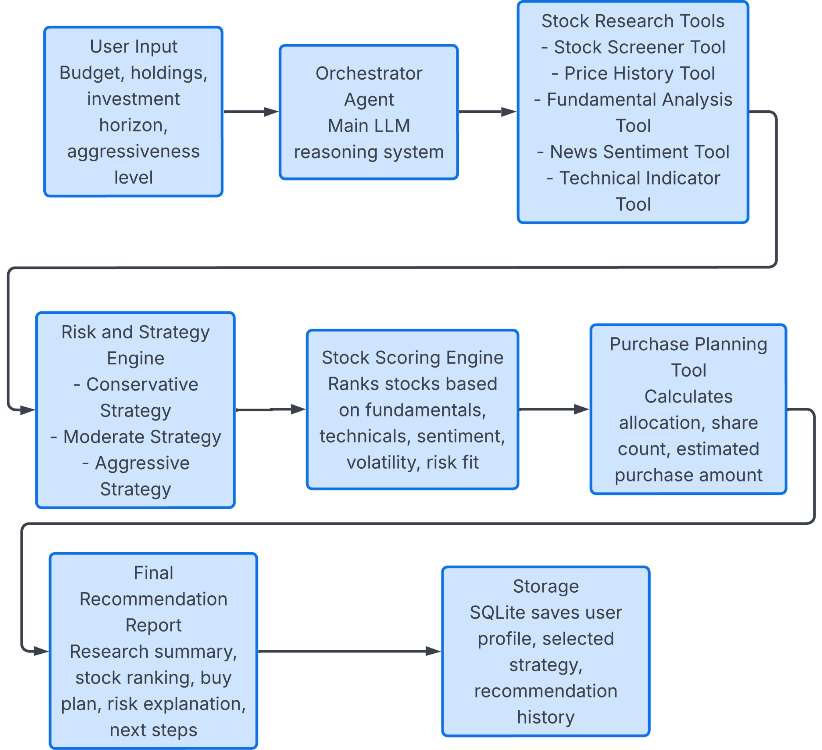
Agentic Design Pattern
The design follows a ReAct style agentic pattern. The orchestrator agent reasons about what information it needs, calls the correct tool, observes the result, and then decides the next step. This pattern fits the project because stock research requires multiple steps. The agent may first screen stocks, then check fundamentals, then review technical indicators, then analyze news, and finally create a purchase plan.
The design is also a hybrid system because not every part depends on the LLM. The LLM is used for reasoning, explanation, and final report generation. However, calculations such as technical indicators, volatility, allocation percentages, and share counts are handled by deterministic tools. This makes the system more reliable and easier to audit. Overall, the agent is designed to work like a Fidelity style research and trading assistant, where the user can research stocks, compare opportunities, choose an aggressiveness level, and receive a clear purchase plan.

